All Rectangles
Geometrically, any rectangle has a unique, well-defined centre point. On a grid this is only true if the sides of the rectangle are an odd number of points long. Since any odd number can be written in the form 2k+1 or 4k+1, we can characterise any such rectangle by specifying k, that is we can say that a rectangle whose length/width is 4k+1/2k+1 has size k. Now define a pattern of rectangles as follows.
- The largest rectangle is of size k (that is length /width is 4k+1/2k+1) is centred in a grid of size 1024 (that is the grid sides are of length 2049).
- The smallest permissible rectangle is of size 1 and the largest is of size 256, thus 1≦k≦256.
- All rectangles of size k > 1 have a square of size k div 2 centred on each of their 4 corners. (Div implies integer division, thus 9 div 2 = 4).
- The top left corner of the screen has coordinates (0,0), the bottom right has coordinates (2048, 2048).
Hence, given a value of k, we can draw a unique pattern of rectangles according to the above rules. Furthermore any point on the screen will be surrounded by zero or more rectangles. (If the point is on the border of a rectangle, it is considered to be surrounded by that rectangle). Thus if the size of the largest rectangle is given as 8, then the following pattern would be produced.
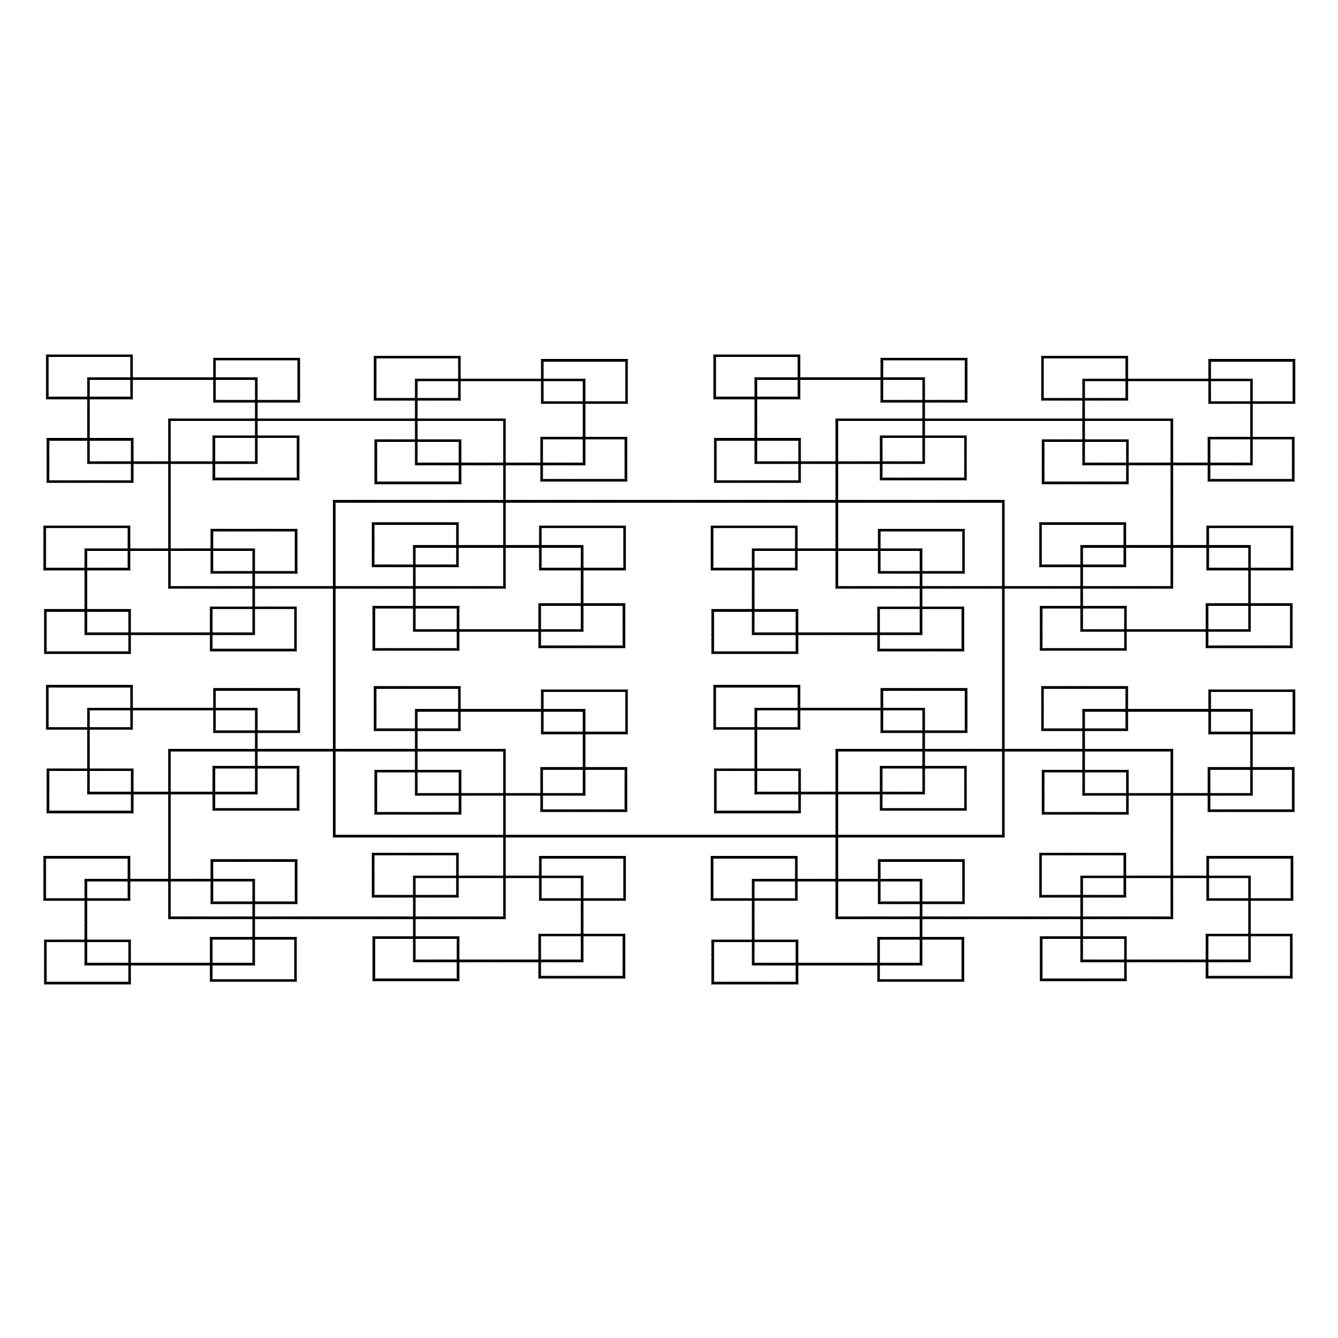
Write a program that will read in a value of k and the coordinates of a point, and will determine how many rectangles surround the point.

Input format
Input will consist of a series of lines. Each line will consist of a value of k and the coordinates of a point. The file will be terminated by a line consisting of three zeroes (0 0 0).

Output format
Output will consist of a series of lines, one for each line of the input. Each line will consist of the number of squares containing the specified point, right justified in a field of width 3.

Sample input

7 1014 1019

216 1000 1000

0 0 0

Sample output
3
2

